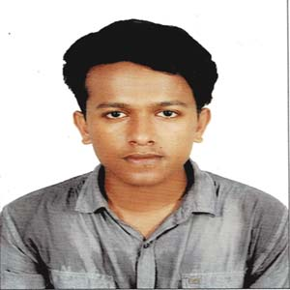**MD NAZMUL ISLAM KHAN**

29 ,Jallapara,

BGB 2 no Gate, Azimpur,

Dhaka-1207

Mobile: +8801999504281

E-mail: nazmul15-13802@diu.edu.bd

**PERSONAL DETAILS:**

Father's Name : Md. Monirul Islam Khan

Mother's Name : Mrs. Naznin Islam

Date of Birth : November 23, 2001

Gender : Male

Marital Status : Single

Nationality : Bangladeshi

Religion : Islam

Permanent Address : 154/1, Education Office Road, Pirojpur.

P.S: Pirojpur, Zilla: Pirojpur-8500.

**EXPERIENCE:**

* Recently data collected and partially analyzed on a research project.
* A team member of a research team of “A World of Three Zeros” project, leading by Prof. Dr. Muhammad Yunus.
* Participated in online cultural programme through Daffodil Prothom Alo Bondhushova Club.
* Had participated in I-gen competition at the district level in 2015.

**SKILLS:**

* Well versed in providing support to group members when required.
* Efficient in handling workloads and have can-do attitude.
* Conversant in developing and implementing innovative ideas.

**LANGUAGE SKILL:**

* English (Good Communication skill both in Oral & Written English)

**ACADEMIC BACKGROUND:**

|  |  |  |  |  |  |
| --- | --- | --- | --- | --- | --- |
| **DEGREE** | **INSTITUTION** | **SUBJECT/ GROUP** | **CGPA (SCALE)** | **PASSING YEAR** | **BOARD/ INSTITUTION** |
| H.S.C | Khulna Public College, Khulna | Science | 4.75(5.00) | 2019 | Jessore |
| S.S.C | Pirojpur Govt. High School, Pirojpur | Science | 5.00(5.00) | 2017 | Barisal |

**COMPUTER SKILLS:**

* **Microsoft Office:** Word, Excel, PowerPoint, Microsoft Project
* **Internet:** Very familiar with Internet Browsing, Downloading, E-mailing etc.

**REFERENCE:**

**Sharun Akter Khushbu**

Lecturer, Department of CSE,

Daffodil International University, Dhaka

Phone:01730-599307

I, the undersigned, certify that to the best of my knowledge and belief, this curriculum vitae correctly describe my qualifications and me.



.........................................

Signature